Ex.no:3 | Data Cleaning

Aim:

Algorithm:
Check Missing Values:
Step 1: Start.
Step 2: Import the pandas library.
Step 3: Load the dataset into a DataFrame (df).
Step 4: Display dataset information using df.info().
Step 5: Check missing values using df.isnull().
Step 6: Count missing values using df.isnull().sum().
Step 7: Check missing values using df.isna().
Step 8: Check non-missing values using df.notnull().
Step 9: Display the results.

Drop Missing Values
Step 1: Start.
Step 2: Import the pandas library.
Step 3: Load the dataset into a DataFrame (df).
Step 4: Drop missing rows using dropna().
Step 5: Drop rows (axis=0) or columns (axis=1).
Step 6: Use how='any' to remove rows/columns containing any missing value.
Step 7: Use how='all' to remove rows/columns only if all values are missing.
Step 8: Use thresh=N to keep rows/columns with at least N non-missing values.
Step 9: Use subset=['column_name'] to drop rows based on specific columns.
Step 10: Use inplace=True to modify the original DataFrame.
Step 11: Display the cleaned DataFrame.

Program:
import pandas as pd

# Load Dataset
df = pd.read_csv("diabetic_data.csv", na_values="?", low_memory=False)

print("===== DATASET INFO =====")
df.info()

print("\n===== MISSING VALUES IN EACH COLUMN =====")
print(df.isnull().sum())

print("\n===== TOTAL MISSING VALUES =====")
print(df.isnull().sum().sum())

print("\n===== ANY MISSING VALUES? =====")
print(df.isnull().values.any())

print("\n===== NON-MISSING VALUES COUNT =====")
print(df.notnull().sum())

# Fill all missing values

import pandas as pd
df = pd.read_csv("diabetic_data.csv", na_values="?", low_memory=False)

# Fill all missing values with a constant value
df_constant = df.fillna("Unknown")
print("===== CONSTANT VALUE =====")
print(df_constant.head())

# Fill race column with mode
df_mode = df.copy()
df_mode["race"] = df_mode["race"].fillna(df_mode["race"].mode()[0])
print("\n===== MODE =====")
print(df_mode.head())

# Fill diagnosis columns with mode
df_diag = df.copy()

df_diag["diag_1"] = df_diag["diag_1"].fillna(df_diag["diag_1"].mode()[0])
df_diag["diag_2"] = df_diag["diag_2"].fillna(df_diag["diag_2"].mode()[0])
df_diag["diag_3"] = df_diag["diag_3"].fillna(df_diag["diag_3"].mode()[0])

print("\n===== DIAGNOSIS MODE =====")
print(df_diag.head())

# Forward Fill
df_ffill = df.ffill()
print("\n===== FORWARD FILL =====")
print(df_ffill.head())

# Backward Fill
df_bfill = df.bfill()
print("\n===== BACKWARD FILL =====")
print(df_bfill.head())

# Drop Missing values
import pandas as pd
df = pd.read_csv("diabetic_data.csv", na_values="?", low_memory=False)

# Drop rows with missing values
df_drop_rows = df.dropna()
print("===== DROP ROWS =====")
print(df_drop_rows.head())

# Drop columns with missing values
df_drop_cols = df.dropna(axis=1)
print("\n===== DROP COLUMNS =====")
print(df_drop_cols.head())

# Drop rows having any missing value
df_any = df.dropna(how="any")
print("\n===== DROP HOW='ANY' =====")
print(df_any.head())

# Drop rows where all values are missing
df_all = df.dropna(how="all")
print("\n===== DROP HOW='ALL' =====")
print(df_all.head())

# Keep rows with at least 40 non-null values
df_thresh = df.dropna(thresh=40)
print("\n===== THRESH=40 =====")
print(df_thresh.head())

# Drop rows where race or diag_1 is missing
df_subset = df.dropna(subset=["race", "diag_1"])
print("\n===== SUBSET (race, diag_1) =====")
print(df_subset.head())

# Drop missing values permanently
df.dropna(inplace=True)
print("\n===== AFTER inplace=True =====")
print(df.head())

Output:

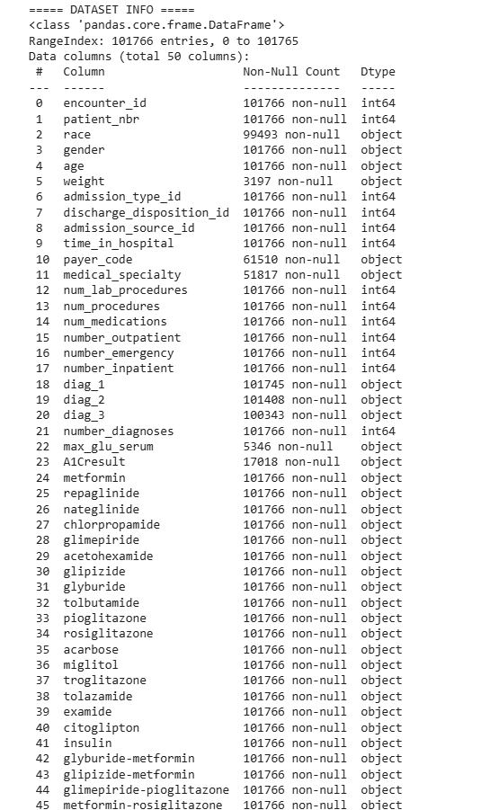
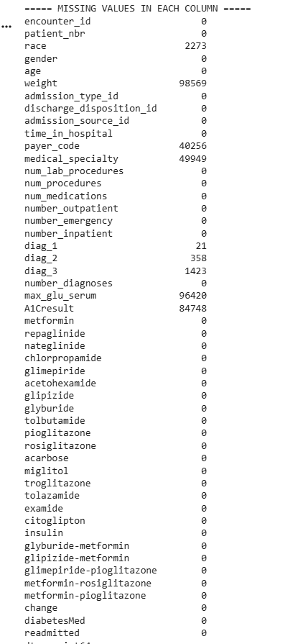

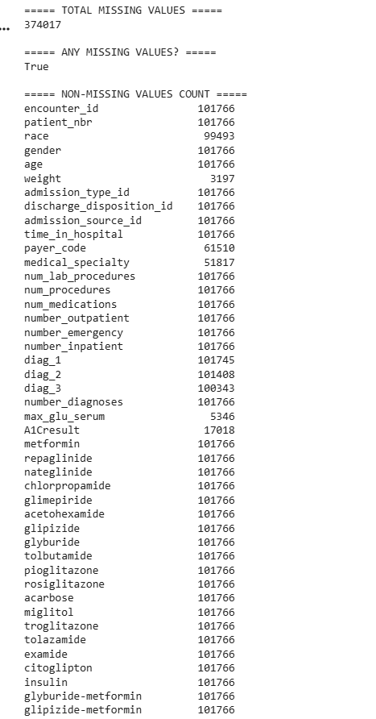

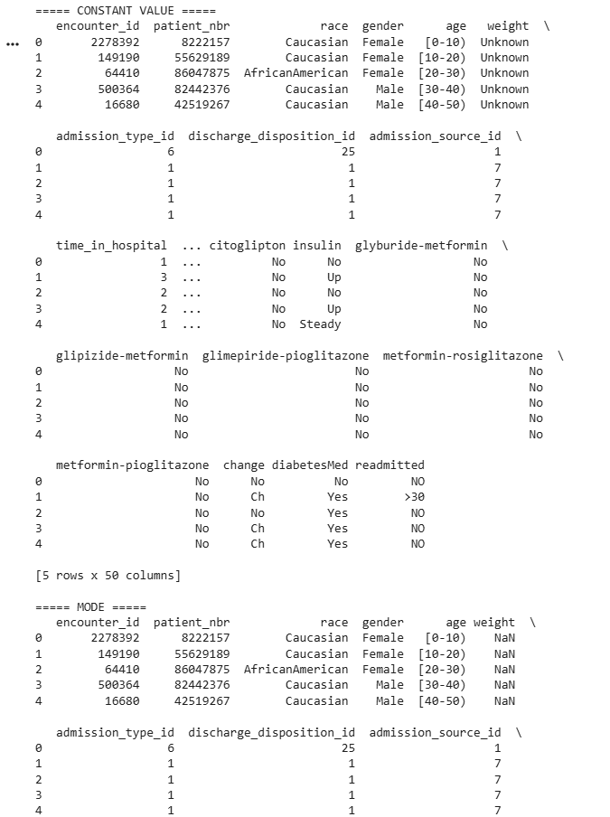

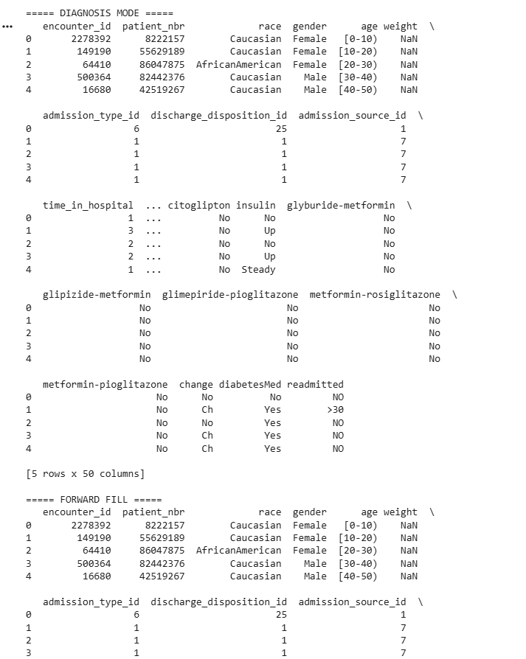

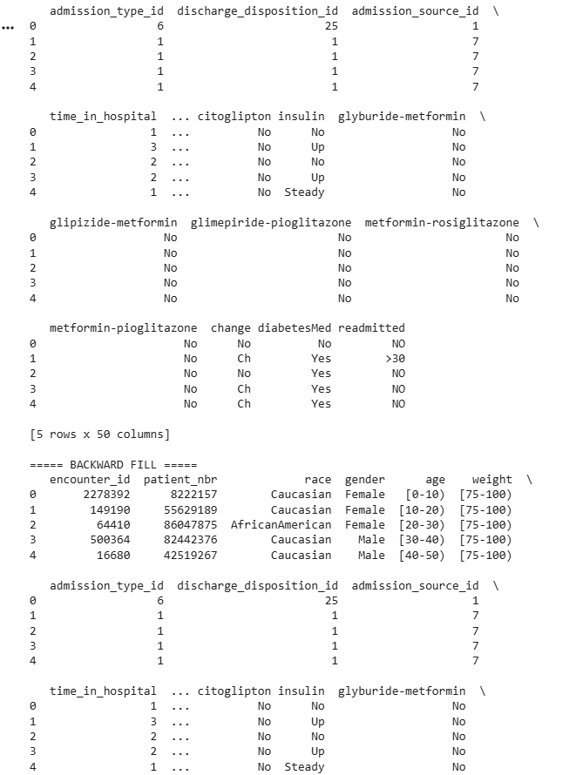

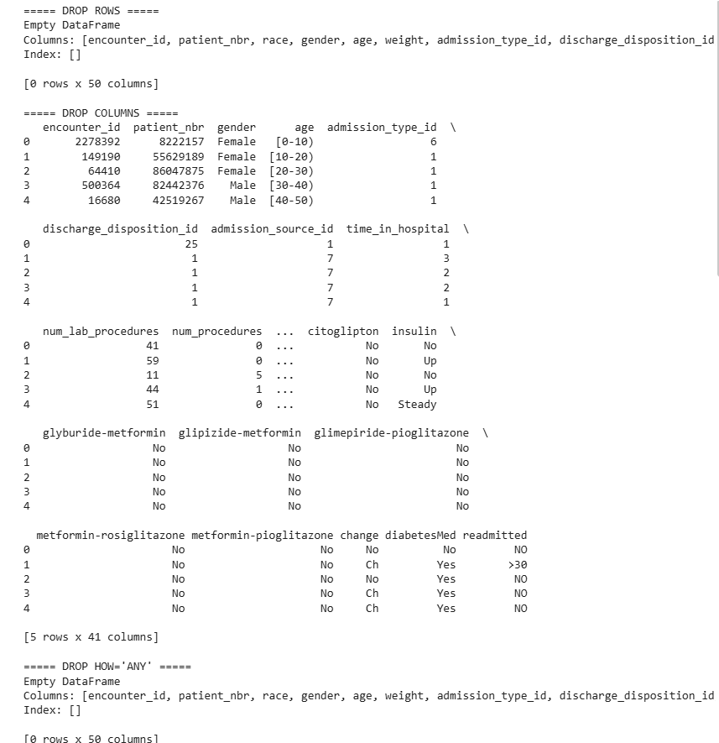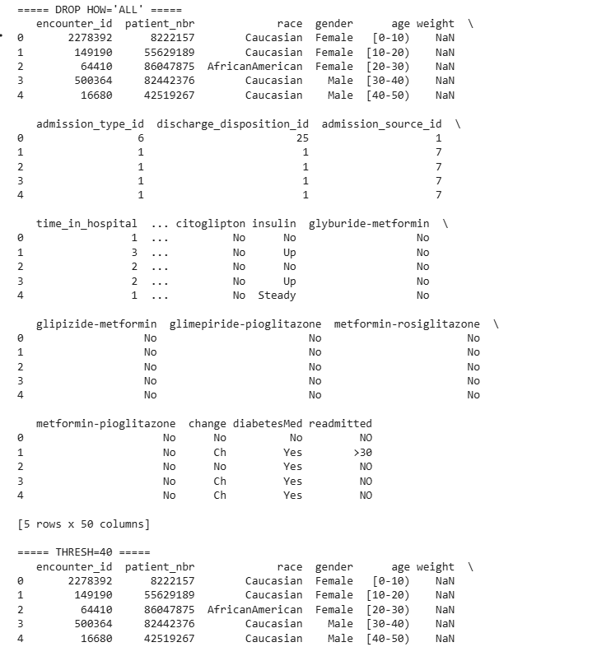

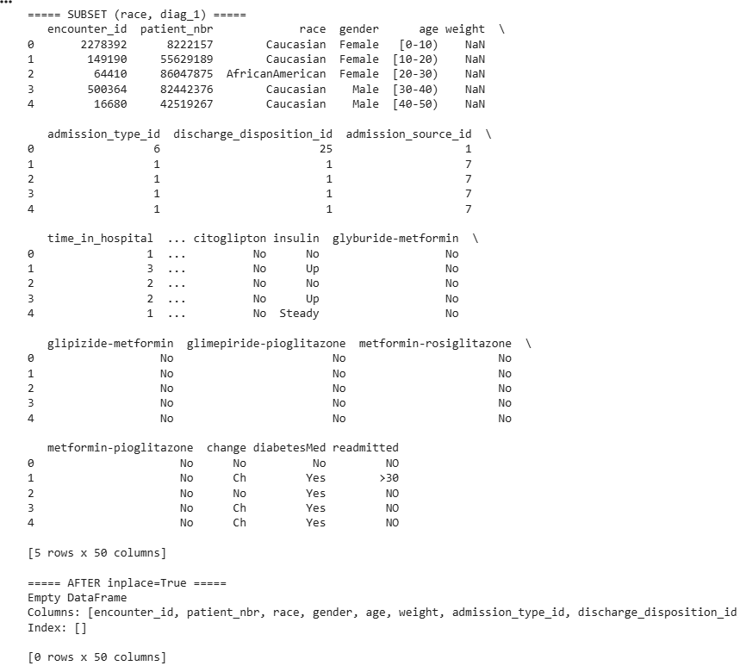

Result:

